PROCEEDINGS OF THE MAYOR AND THE BOARD OF ALDERMEN OF THE CITY OF RAYNE, STATE OF LOUISIANA, TAKEN AT A REGULAR MEETING, HELD ON September 8, 2025.

The Mayor and Board of Aldermen of the City of Rayne, Louisiana, met for a Budget Hearing at 5:15 p.m. followed by the regular session at 6:00 p.m. at their regular meeting place the City Hall, Rayne, Louisiana, on Monday, September 8, 2025.

There were present: Mayor Charles E. “Chuck” Robichaux, Brian Seth Mouton, Kenneth J. Guidry, Lendell J. “Pete” Babineaux, Calise Michael Doucet and James A. “Jimmy” Fontenot.

The Mayor and the Board of Aldermen of the City of Rayne, State of Louisiana, were duly convened as the governing authority of said City, by Mayor Charles E. “Chuck” Robichaux, who stated that the Board was ready for the transaction of business.

On a motion by Brian Seth Mouton and a second by Kenneth J. Guidry the Budget Hearing was opened for the purpose of a public discussion on:

- Ordinance #2054-2025 - An Ordinance to amend the City of Rayne’s October 1, 2024 – September 30, 2025 Budget.

- Ordinance #2055-2025 - An Ordinance to adopt an Operating Budget of Revenues and Expenditures for the fiscal year beginning October 1, 2025 and ending September 30, 2026.
YEAS: 5 - Brian Seth Mouton, Kenneth J. Guidry, Lendell J. “Pete” Babineaux, Calise Michael Doucet and James A. “Jimmy” Fontenot.
NAYS: 0 ABSTAIN: 0 ABSENT: 0

There were no speaker cards so other than budget presentations by Burton Kolder with Kolder, Slaven & Company, LLC., with questions from the Council and Mayor, there were no public comments.

CITY OF RAYNE
BUDGET CERTIFICATION NOTICE
FOR FISCAL YEAR 10-01-2025 – 09-30-2026

This is to certify that the City of Rayne has complied with Louisiana Revised Statute 39:1307 relative to public participation in the budget process for the Fiscal Year Ended September 30, 2026.

- A notice of availability for public inspection was published in the official journal, The Rayne Acadian-Tribune, August 28, 2025.

- A public Budget Hearing was held on Monday, September 8, 2025, at 5:15 p.m., Local Time, in the Council Chambers of Rayne City Hall, at which time Ordinance #2055-2025 for the 10/1/2025 – 9/30/2026 budget for the City of Rayne was discussed, in compliance with applicable statute.

On a motion by James A. “Jimmy” Fontenot and a second by Calise Michael Doucet the Budget Hearing was closed.
YEAS: 5 - Brian Seth Mouton, Kenneth J. Guidry, Lendell J. “Pete” Babineaux, Calise Michael Doucet and James A. “Jimmy” Fontenot.
NAYS: 0 ABSTAIN: 0 ABSENT: 0

There was a motion by Lendell J. “Pete” Babineaux to approve, correct, and dispense with the reading of minutes of the August 2025 regular council meeting and approved them as written and distributed. This was seconded by Kenneth J. Guidry, and motion carried.
YEAS: 5 - Brian Seth Mouton, Kenneth J. Guidry, Lendell J. “Pete” Babineaux, Calise Michael Doucet and James A. “Jimmy” Fontenot.
NAYS: 0 ABSTAIN: 0 ABSENT: 0

The following ordinance was offered by Kenneth J. Guidry and seconded by Calise Michael Doucet and duly resolved and adopted on this 8th day of September 2025.

ORDINANCE NO. 2054-2025

AN ORDINANCE ADOPTING AN AMENDED OPERATING BUDGET OF REVENUES AND EXPENDITURES FOR THE FISCAL YEAR BEGINNING OCTOBER 1, 2024 AND ENDING SEPTEMBER 30, 2025 – See attached Budget FYE 9/30/25 – estimated amounts.

BE IT ORDAINED by the Board of Councilmen of the City of Rayne, State of Louisiana, in general session convened that:

SECTION 1: The attached detailed estimate of Revenues for the fiscal year beginning October 1, 2024 and ending September 30, 2025, be and the same is hereby adopted to serve as an Operation Budget of Revenues for the City of Rayne, during the same period.

SECTION 2: The attached estimates of Expenditures by departments for the fiscal year beginning October 1, 2024, and ending September 30, 2025, be and the same is hereby adopted to serve as a budget of Expenditures for the City of Rayne during the same period.

SECTION 3: The adoption of this Operating Budget of Expenditures be and the same is hereby declared to operate as an appropriation of the amount therein set forth within the terms of the budget classification.

SECTION 4: Amounts are available for expenditures only to the extent included with the 2024-2025 budget document, presented as Estimated amounts.

SECTION 5: The Mayor of the City of Rayne shall have the authority to make changes within each department’s operating budget to the extent that the department’s total budget allocation is not modified without approval by the governing authority (Board of Councilmen). Modifications which change a department’s total budget allocation must be approved by the Board of Councilmen. Additionally, all modifications to budgeted capital outlay must be approved by the Board of Councilmen.

The above ordinance was adopted on a vote taken by yeas and nays entered on the minutes of the clerk as follows:
YEAS: 5 - Brian Seth Mouton, Kenneth J. Guidry, Lendell J. “Pete” Babineaux, Calise Michael Doucet and James A. “Jimmy” Fontenot.
NAYS: 0 ABSTAIN: 0 ABSENT: 0

The ordinance is declared PASSED AND ADOPTED AT CITY OF RAYNE, STATE OF LOUISIANA, on this 8th day of September 2025.

ATTEST:

______________________________________ __________________________________
ANGELIQUE N. BREAUX, CITY CLERK CHARLES E. ROBICHAUX, MAYOR

The above ordinance was presented to the Mayor by the Clerk, approved by the Mayor and returned to the Clerk on this 8th day of September 2025.

______________________________________ __________________________________
ANGELIQUE N. BREAUX, CITY CLERK CHARLES E. ROBICHAUX, MAYOR

The following ordinance was offered by Lendell J. “Pete” Babineaux and seconded by Calise Michael Doucet and duly resolved and adopted on this 8th day of September 2025.

ORDINANCE NO. 2055-2025

AN ORDINANCE ADOPTING AN OPERATING BUDGET OF REVENUES AND EXPENDITURES FOR THE FISCAL YEAR BEGINNING OCTOBER 1, 2025 AND ENDING SEPTEMBER 30, 2026 – See attached Budget FYE 9/30/26.

BE IT ORDAINED by the Board of Councilmen of the City of Rayne, State of Louisiana, in general session convened that:

SECTION 1: The attached detailed estimate of Revenues for the fiscal year beginning October 1, 2025 and ending September 30, 2026, be and the same is hereby adopted to serve as an Operation Budget of Revenues for the City of Rayne, during the same period.

SECTION 2: The attached estimates of Expenditures by departments for the fiscal year beginning October 1, 2025, and ending September 30, 2026, be and the same is hereby adopted to serve as a budget of Expenditures for the City of Rayne during the same period.

SECTION 3: The adoption of this Operating Budget of Expenditures be and the same is hereby declared to operate as an appropriation of the amount therein set forth within the terms of the budget classification.

SECTION 4: Amounts are available for expenditures only to the extent included with the 2025-2026 budget.

SECTION 5: The Mayor of the City of Rayne shall have the authority to make changes within each department’s operating budget to the extent that the department’s total budget allocation is not modified without approval by the governing authority (Board of Councilmen). Modifications which change a department’s total budget allocation must be approved by the Board of Councilmen. Additionally, all modifications to budgeted capital outlay must be approved by the Board of Councilmen.

The above ordinance was adopted on a vote taken by yeas and nays entered on the minutes of the clerk as follows:
YEAS: 4 - Brian Seth Mouton, Kenneth J. Guidry, Lendell J. “Pete” Babineaux, and Calise Michael Doucet.
NAYS: 1 - James A. “Jimmy” Fontenot ABSTAIN: 0 ABSENT: 0

The ordinance is declared PASSED AND ADOPTED AT CITY OF RAYNE, STATE OF LOUISIANA, on this 8th day of September 2025.

ATTEST:

_____________________________________ __________________________________
ANGELIQUE N. BREAUX, CITY CLERK CHARLES E. ROBICHAUX, MAYOR

The above ordinance was presented to the Mayor by the Clerk, approved by the Mayor and returned to the Clerk on this 8th day of September 2025.

_____________________________________ __________________________________
ANGELIQUE N. BREAUX, CITY CLERK CHARLES E. ROBICHAUX, MAYOR

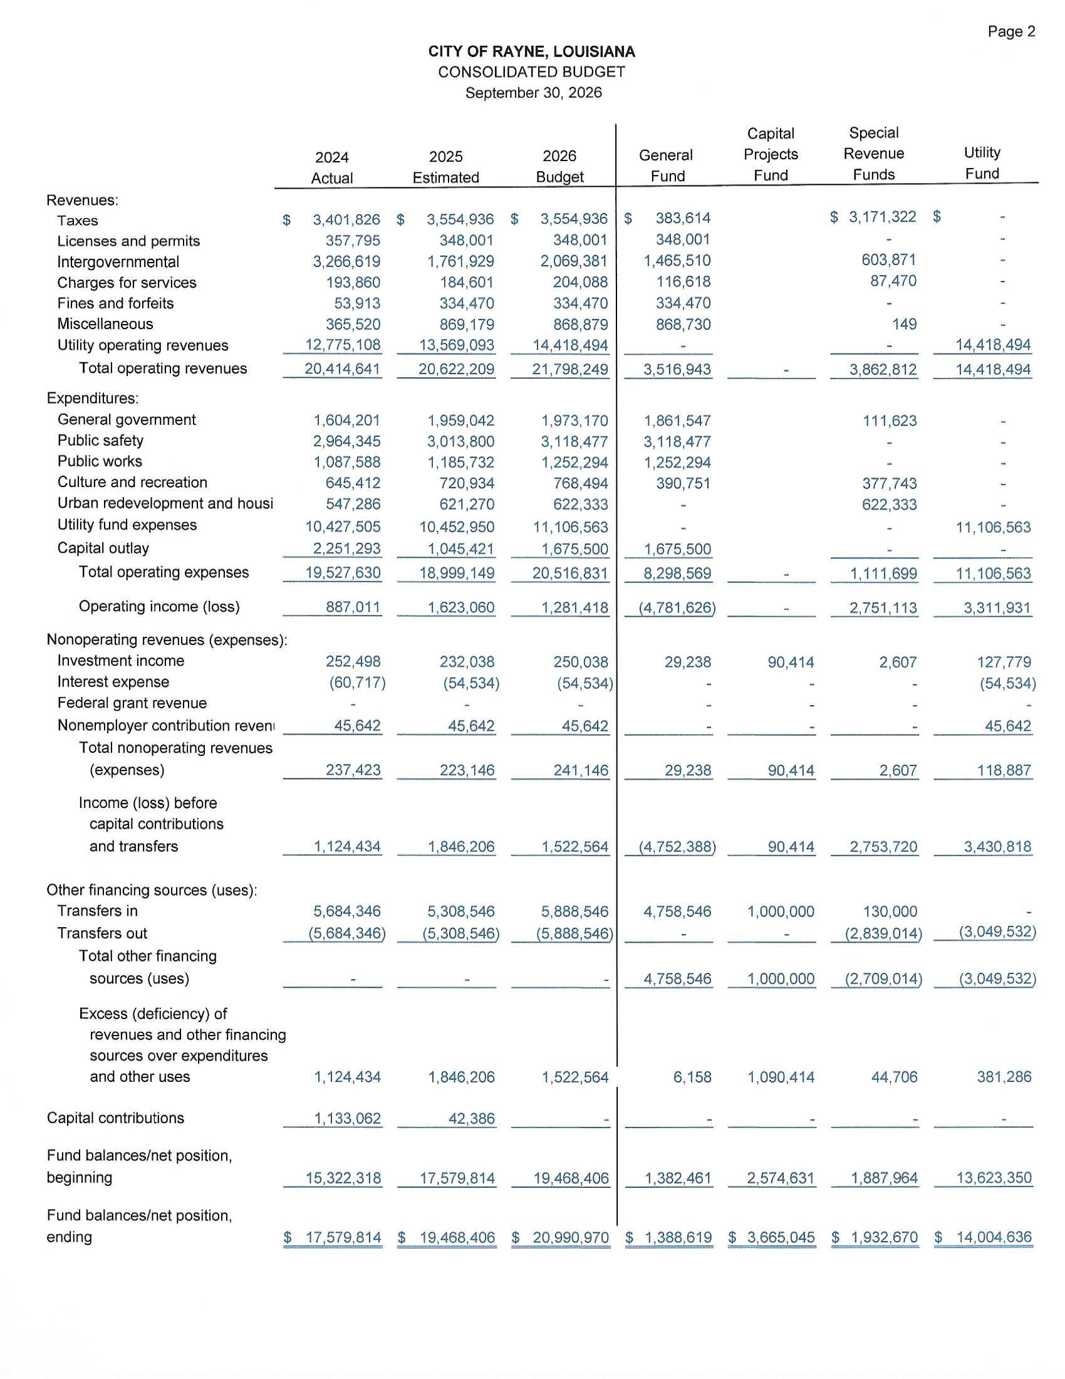
On a motion by James A. “Jimmy” Fontenot and a second by Calise Michael Doucet the City of Rayne financials for August 2025 which included budget to actual comparisons on the major funds was accepted by the Council.
YEAS: 5 - Brian Seth Mouton, Kenneth J. Guidry, Lendell J. “Pete” Babineaux, Calise Michael Doucet and James A. “Jimmy” Fontenot.
NAYS: 0 ABSTAIN: 0 ABSENT: 0

It was announced that there will be a “TAKE BACK THE NIGHT”, Domestic Violence Candlelight Vigil on Sunday, October 5, 2025 from 6:00pm until 7:00pm. The walk will take place from the American Legion to The Depot followed by a brief program. It is dedicated in memory of Allen “Noochie” Credeur.

Beau Petitjean, President of the Acadia Parish Police Jury announced a meeting of the Acadia Parish First Ward Drainage District on Monday, September 22, 2025 at 5:30pm at the Mural Room. Discussion will be about drainage concerns of the Lyons Point Gulley.

On a motion by James A. “Jimmy” Fontenot and a second by Calise Michael Doucet the owner of 402 Live Oak – Gulfsouth Land Holdings, LLC was given 30 days to demolish the house.
YEAS: 5 - Brian Seth Mouton, Kenneth J. Guidry, Lendell J. “Pete” Babineaux, Calise Michael Doucet and James A. “Jimmy” Fontenot.
NAYS: 0 ABSTAIN: 0 ABSENT: 0

The Engineer’s Report was presented by Tim Mader.

It was noted that on a change order approved at the August 2025 meeting for the Gossen Park Concession Stand that for the adjusted costs not covered by the State will be paid using city funds.

There being no further business to come before the Council, there was a motion by James A. “Jimmy” Fontenot and a second by Kenneth J. Guidry and carried.
YEAS: 5 - Brian Seth Mouton, Kenneth J. Guidry, Lendell J. “Pete” Babineaux, Calise Michael Doucet and James A. “Jimmy” Fontenot.
NAYS: 0 ABSTAIN: 0 ABSENT: 0

_____________________________________ ___________________________________
ANGELIQUE N. BREAUX, CITY CLERK CHARLES E. ROBICHAUX, MAYOR

